|  |
| --- |
| **E:\My Documents\Desktop\Logo_FPT_University_doc.jpg** |
| Capstone Project Introduction |
|  |
|  |
| **Rental House Finding System Team | FPT University** |
| **Hanoi, 15th Jan 2013** |

|  |
| --- |
|  |

Table of Contents

[I. Introduction 3](#_Toc290942897)

[1. Project Information 3](#_Toc290942898)

[2. Purposes 3](#_Toc290942899)

[3. Background 4](#_Toc290942901)

[4. Literature Review of Existing Systems 4](#_Toc290942902)

[5. Our Proposal 5](#_Toc290942903)

[6. Products 5](#_Toc290942904)

[II. References 6](#_Toc290942905)

# Introduction

## Project Information

* Project name: **Rental House Finding System**
* Project code: **RHF**
* Product type: **Website**
* Timeline: **from Jan 2013 to Apr 2013**

## Purposes

This project is registered and implemented as the capstone project for the team members. The first purpose is to fulfill the requirements from FPT University studying program. The second purpose is to create a complete product for going live.

## Background

Nowadays, in the big cities such as Hanoi and Ho Chi Minh have many job opportunities, good infrastructures, universities and living standard. Therefore, a large number of people and students come from other provinces to work and study. The need of finding a house for lease is definitely becoming very popular and necessary.

Normally, people spend lots of time for asking friends or try to go around and around to find a suitable flat.

Coming with the fast developing of communication technology, other people could also find house by surfing websites on the Internet. There is a lot of information on the Internet. However, there are still lots of unnecessary information, out of date information of rental rooms, flats, and houses. As a result, people must spend lots of time for searching suitable one.

Base on ideas of building web application to help people find their suitable rental house and creating the connection between house owners and renters. Our website will help renters to find house for lease more easily and efficiently, the lords have a faster & better way to approach their potential renters.

Hopefully, our website will be a bridge of connecting between house owners and people who want to lease the house.

## Literature Review of Existing Systems

Currently, there are some popular systems with quite similar services in comparison to our system, both in Vietnam and worldwide such as: <http://www.xomtrosv.com>, <http://www.nhatroviet.com> & <https://www.padmapper.com>

**XomtroSV.com**: In overview, this website has supported users quite well with many general features of a standard advertisement website; however:

* + - Website does not have comparing between similar topics.
    - It does not have view history and save favorites function.
    - It supports Google map but with limitation function implemented on this.



**nhatroViet.com**:

* + - Each post has enough information: address, room type, date, rent, electric and water fees, contacts, etc.
    - Suggestion shows rooms on the same district.
    - Provide more related information that user may need:
      * News related to room seeking, giving user more information.
      * Can search for buses by number or by route.
    - No bookmark and rating
    - Google Map implementation has bug
    - Suggestion doesn’t show rooms on the same district, which helps users compare among candidate selections.

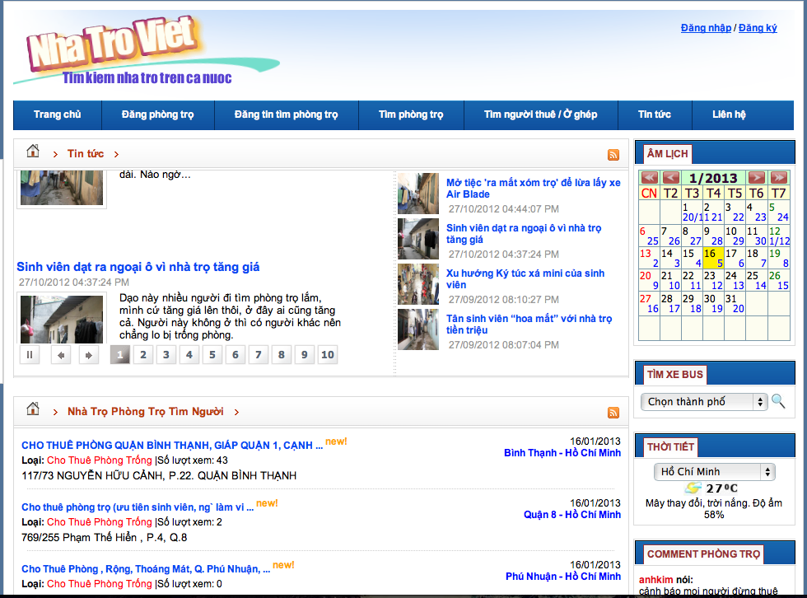

**Padmapper.com**:

* + - It has visual interaction:
      * Support of nearly full screen map.
      * Has markers on the map, which helps users identify the location better.
      * It has visual scrolls for users to set range of their search.
    - Favorite list for users to refer later.
    - No comparison function between 2 or more positions.
    - No suggestion for other places near selected positions such as universities, markets, and hospitals…

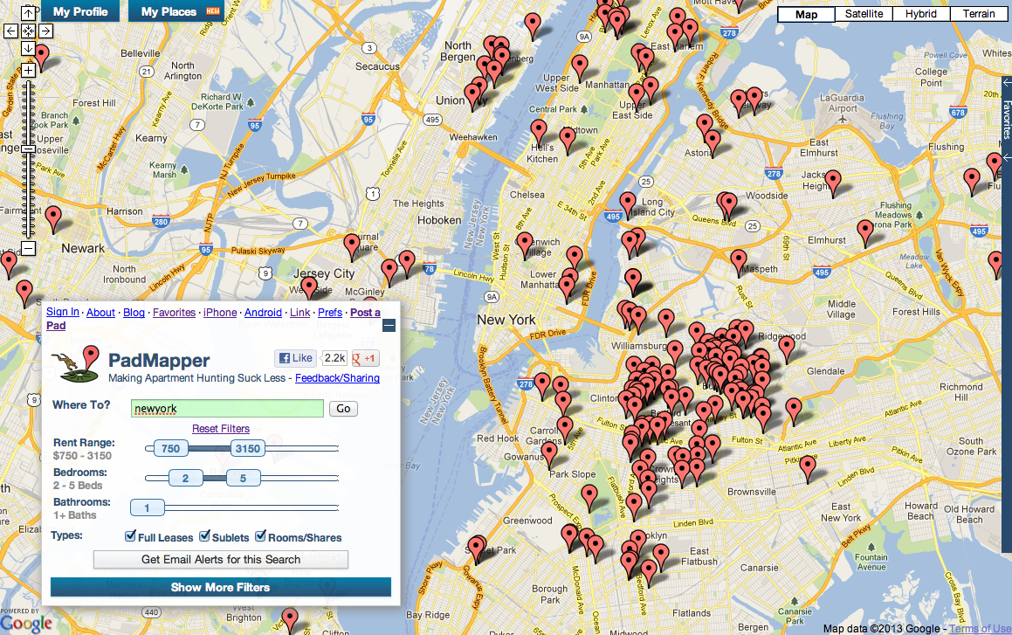

## Our Proposal

The idea of creating a website supports finding rental house is not new. However, our website has a proposal brings better & faster way of searching, better user experiences. We focus on the following points:

* + Quick search function: should be faster, more efficient with suggestion of good and suitable houses, flats for users.
  + Advanced Search: focus on users who know well their needs and want to find the best ones for them with their own evaluation of necessary living conditions.
  + Visualization: Improve the interaction between users and visual maps in friendly & direct ways.
  + Simple flows of interaction: between user and website which helps users approached main functions faster and more easily with implementation of Google Map Api, OpenID, simple SMS post activation…

## Products

The main product of this project is a website as mentioned above. Users will use the website to search, compare, decide to contact the house owner. Besides, user also save favorite, share, Q&A, review, update post and so on.

# References

* <http://xomtrosv.com>
* <http://nhatroviet.com>
* <http://padmapper.com>